Week - 2
PL/SQL programming

Exercise 1: Control Structures

Project Name : ControlStructures
Exercise : Implementing PL/SQL Using Control Structures
Name : Kotha Akanksha
Superset Id : 6373762

- Introduction :
This document presents PL/SQL solutions using control structures for a banking database. The goal is to manipulate customer and loan records using conditional and iterative logic.

- Implementation :
Step 1: Establish New Connection
Step 2: Create Tables and Insert Values

CREATE DATABASE bank_control;

USE bank_control;

CREATE TABLE Customers (
CustomerID INT PRIMARY KEY,
Name VARCHAR(100),
Age INT,
Balance DECIMAL(10,2),
IsVIP BOOLEAN DEFAULT FALSE
);

CREATE TABLE Loans (
LoanID INT PRIMARY KEY,
CustomerID INT,
InterestRate DECIMAL(5,2),
DueDate DATE,
FOREIGN KEY (CustomerID) REFERENCES Customers(CustomerID)
);

INSERT INTO Customers VALUES
(1, 'John', 65, 12000.00, FALSE),
(2, 'Alice', 45, 8000.00, FALSE),
(3, 'Bob', 70, 15000.00, FALSE);

INSERT INTO Loans VALUES
(101, 1, 7.5, CURDATE() + INTERVAL 10 DAY),
(102, 2, 8.0, CURDATE() + INTERVAL 35 DAY),
(103, 3, 6.5, CURDATE() + INTERVAL 5 DAY);

SCENARIO 1:

DELIMITER $$

CREATE PROCEDURE ApplySeniorDiscount()
BEGIN
DECLARE done INT DEFAULT FALSE;
DECLARE custId INT;

DECLARE cur CURSOR FOR
SELECT CustomerID FROM Customers WHERE Age > 60;

DECLARE CONTINUE HANDLER FOR NOT FOUND SET done = TRUE;

OPEN cur;
read_loop: LOOP
FETCH cur INTO custId;
IF done THEN
LEAVE read_loop;
END IF;

UPDATE Loans
SET InterestRate = InterestRate - 1
WHERE CustomerID = custId;
END LOOP;

CLOSE cur;
END$$

DELIMITER ;

CALL ApplySeniorDiscount();

SELECT * FROM Loans;

Loans Table After Scenario 1:

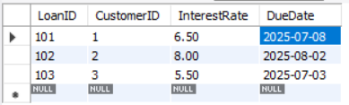

Scenario2:

UPDATE Customers
SET IsVIP = TRUE
WHERE Balance > 10000;

SELECT * FROM Customers;

Outputs :

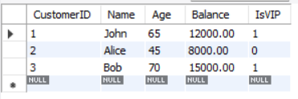

SCENARIO 3:

DELIMITER $$

CREATE PROCEDURE SendLoanReminders()
BEGIN
DECLARE done INT DEFAULT FALSE;
DECLARE custName VARCHAR(100);
DECLARE dueDate DATE;

DECLARE cur CURSOR FOR
SELECT C.Name, L.DueDate
FROM Customers C
JOIN Loans L ON C.CustomerID = L.CustomerID
WHERE L.DueDate <= CURDATE() + INTERVAL 30 DAY;

DECLARE CONTINUE HANDLER FOR NOT FOUND SET done = TRUE;

OPEN cur;
FETCH cur INTO custName, dueDate;

WHILE NOT done DO
SELECT CONCAT('Reminder: ', custName, ', your loan is due on ', dueDate) AS Reminder;
FETCH cur INTO custName, dueDate;
END WHILE;

CLOSE cur;
END$$

DELIMITER ;

CALL SendLoanReminders();

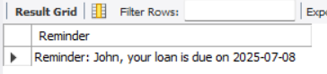

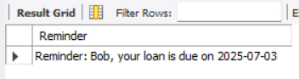

Exercise 2 : Stored Procedures

Project Name : Stored Procedures(Banking Example)
Exercise : Implementing PL/SQL Using Stored Procedures
Name : Kotha Akanksha
Superset Id : 6373762

- Introduction :
This exercise demonstrates the use of PL/SQL stored procedures to automate key banking operations. It includes:
- Applying monthly interest to savings accounts
- Updating employee salaries with performance bonuses
- Transferring funds between customer accounts
These scenarios help develop skills in writing procedures, handling input parameters, and applying conditional logic in PL/SQL.
- Implementation :
Step 1: Create Tables and Insert Values

CREATE DATABASE bankdb_ex3;
USE bankdb_ex3;
SCENARIO 1
CREATE TABLE SavingsAccounts (
AccountID INT PRIMARY KEY,
CustomerName VARCHAR(100),
Balance DECIMAL(10,2)
);
INSERT INTO SavingsAccounts VALUES
(1, 'John', 10000.00),
(2, 'Alice', 15000.00),
(3, 'Bob', 20000.00);
DELIMITER $$
CREATE PROCEDURE ProcessMonthlyInterest()
BEGIN
UPDATE SavingsAccounts
SET Balance = Balance + (Balance * 0.01);
END$$
DELIMITER ;
CALL ProcessMonthlyInterest();
SELECT * FROM SavingsAccounts;
Output:
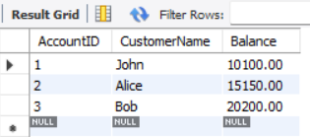

Scenario 2: Bonus Scheme for Employees

CREATE TABLE Employees (
EmpID INT PRIMARY KEY,
Name VARCHAR(100),
Department VARCHAR(100),
Salary DECIMAL(10,2)
);
DELIMITER $$

CREATE PROCEDURE UpdateEmployeeBonus(
IN deptName VARCHAR(100),
IN bonusPercent DECIMAL(5,2)
)
BEGIN
UPDATE Employees
SET Salary = Salary + (Salary * bonusPercent / 100)
WHERE LOWER(Department) = LOWER(deptName);
END$$

DELIMITER ;

CALL UpdateEmployeeBonus('IT', 10);

SELECT * FROM Employees;

OUTPUT:
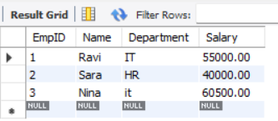

SCENARIO 3:

CREATE TABLE Accounts (
AccountNumber INT PRIMARY KEY,
HolderName VARCHAR(100),
Balance DECIMAL(10,2)
);
INSERT INTO Accounts VALUES
(101, 'John', 8000.00),
(102, 'Alice', 6000.00);
DELIMITER $$

CREATE PROCEDURE TransferFunds(
IN fromAccount INT,
IN toAccount INT,
IN amount DECIMAL(10,2)
)
BEGIN
DECLARE fromBalance DECIMAL(10,2);

SELECT Balance INTO fromBalance
FROM Accounts
WHERE AccountNumber = fromAccount;

IF fromBalance >= amount THEN
UPDATE Accounts
SET Balance = Balance - amount
WHERE AccountNumber = fromAccount;

UPDATE Accounts
SET Balance = Balance + amount
WHERE AccountNumber = toAccount;
ELSE
SIGNAL SQLSTATE '45000'
SET MESSAGE_TEXT = 'Insufficient funds in source account';
END IF;
END$$

DELIMITER ;

CALL TransferFunds(101, 102, 2000);

SELECT * FROM Accounts;

OUTPUT:
